
Faculty of Computing Information

[CIT 6234 Advanced Database]
[Assignment 1]

Data Warehouse for Online Grocery System

Lecture Session: TC1L / Tutorial Session: TT2L
Student Name | Student ID
Ku Jing Hao | 1201203310
Lim Jun Jie | 1201103290
Lim Sir Yuean | 1211307746
Yap Jack | 1211103024

Contents
1. Conceptual Schema for Data Warehouse 3
2. Data Dictionary 4
3. Fact Table Size and Storage in Database Schema 7
4. Data Definition Language (DDL) 8
5. Data Manipulation Language (DML) 11
5.1 Supplier Table 13
5.2 Product Table 13
5.3 Promotion Table 14
5.4 Delivery Table 14
5.5 Customer Table 14
5.6 Time Dimension Table 15
5.7 Payment Table 15
5.8 Sales Table 15
6. Procedural SQLs 16
6.1 Stored Procedure 16
6.1.1 GetCustomerSummary 16
6.1.2 AutoInsert 17
6.2 Trigger 21
6.2.1 AfterSaleInsert 21
6.2.2 PreventDuplicate 22
6.3 User-Defined Functions 24
7. Construct SQLs 26
7.1 Complex Query with Joins of at Least 3 Tables 26
7.2 Group by/Group by Rollup/Group by Cube and Having Clause 27
7.3 View 29
7.4 Two SQL Not Covered in Lecture 30

1. Conceptual Schema for Data Warehouse
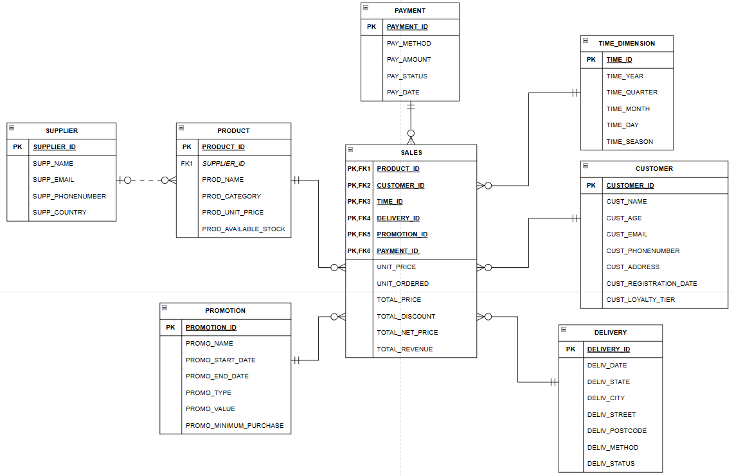
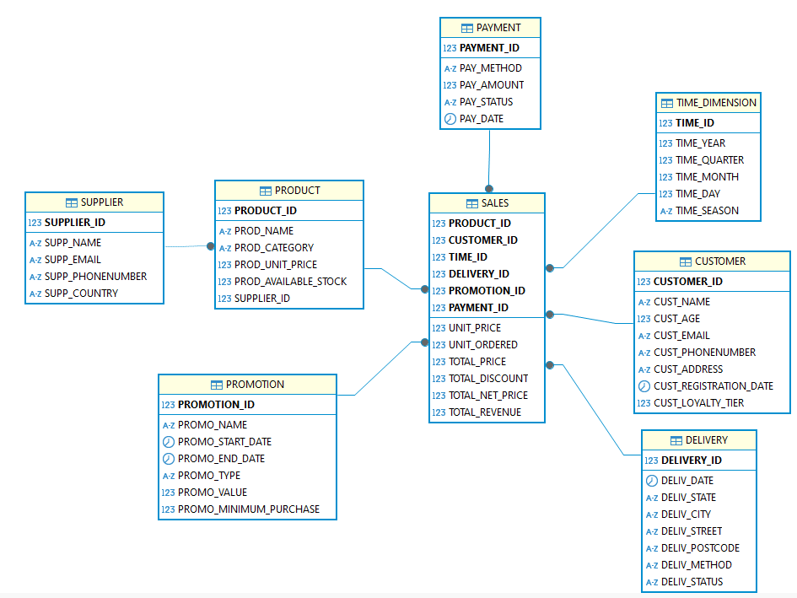

2. Data Dictionary
Table Name | Attribute Name | Contents | Data Type | Format | Range | Required | PK or FK | FK Reference Table
SALES | PRODUCT_ID | Product identifier | INT | 9999 |  | Y | PK, FK | PRODUCT
 | CUSTOMER_ID | Customer identifier | INT | 9999 |  | Y | PK, FK | CUSTOMER
 | TIME_ID | Time identifier | INT | 9999 |  | Y | PK, FK | TIME
 | DELIVERY_ID | Delivery identifier | INT | 9999 |  | Y | PK, FK | DELIVERY
 | PROMOTION_ID | Promotion identifier | INT | 9999 |  | Y | PK, FK | DISCOUNT
 | PAYMENT_ID | Payment identifier | INT | 9999 |  | Y | PK, FK | PAYMENT
 | UNIT_PRICE | Price per unit of the product | DECIMAL(6,2) | 9,999.99 |  | Y
 | UNIT_ORDERED | Number of units ordered | INT | 9999 |  | Y
 | TOTAL_PRICE | Final sales amount | DECIMAL(9,2) | 9,999,999.99 |  | Y
 | TOTAL_DISCOUNT | Total discount applied | DECIMAL(9,2) | 9,999,999.99 |  | Y
 | TOTAL_NET_PRICE | Final price after discount | DECIMAL(9,2) | 9,999,999.99 |  | Y
 | TOTAL_REVENUE | Final revenue generated from sale | DECIMAL(9,2) | 9,999,999.99 |  | Y
PRODUCT | PRODUCT_ID | Product identifier | INT | 9999 |  | Y | PK
 | PROD_NAME | Product name | VARCHAR(50) | Xxxxxxxxxx |  | Y
 | PROD_CATEGORY | Product category | VARCHAR(50) | Xxxxxxxxxx |  | Y
 | PROD_UNIT_PRICE | Unit price of the product | DECIMAL(6,2) | 9,999.99 |  | Y
 | PROD_AVAILABLE_STOCK | Available stock quantity | INT | 9999 |  | Y
 | SUPPLIER_ID | Supplier identifier | INT | 9999 |  | Y | FK | SUPPLIER
PROMOTION | PROMOTION_ID | Discount identifier | INT | 9999 |  | Y | PK
 | PROMO_NAME | Name of the promotion | VARCHAR(50) | Xxxxxxxxxx |  | Y
 | PROMO_START_DATE | Start date of the promotion | DATE | YYYY-MM-DD |  | Y
 | PROMO_END_DATE | End date of the promotion | DATE | YYYY-MM-DD |  | Y
 | PROMO_TYPE | Type of promotion | VARCHAR(50) | Xxxxxxxxxx |  | Y
 | PROMO_VALUE | Value of the discount | DECIMAL(6,2) | 9,999.99 |  | Y
 | PROMO_MINIMUM_PURCHASE | Minimum purchase amount for promotion | DECIMAL(6,2) | 9,999.99 |  | Y
TIME_DIMENSION | TIME_ID | Time identifier | INT | 9999 |  | Y | PK
 | TIME_YEAR | Year of transaction | INT | 9999 |  | Y
 | TIME_QUARTER | Quarter of the year | INT | 9 | 1 - 4 | Y
 | TIME_MONTH | Month of the year | INT | 99 | 1 - 12 | Y
 | TIME_DAY | Day of the month | INT | 99 | 1 - 31 | Y
 | TIME_SEASON | The season of the year (spring, summer, autumn, and winter) | VARCHAR(6) | Xxxxxx |  | Y
CUSTOMER | CUSTOMER_ID | Customer identifier | INT | 9999 |  | Y | PK
 | CUST_NAME | Customer name | VARCHAR(50) | Xxxxxxxxxx |  | Y
 | CUST_AGE | Customer age | SMALLINT(2) | 99 | 0 - 100 | Y
 | CUST_EMAIL | Customer Email | VARCHAR(50) | xxx@xxxxxx.xxx |  | Y
 | CUST_PHONENUMBER | Customer phone number | VARCHAR(15) | xxxxxxxxxx |  | N
 | CUST_ADDRESS | Customer address | VARCHAR(100) | xxxxxxxxxx |  | N
 | CUST_REGISTRATION_DATE | Customer registration date | DATE | YYYY-MM-DD |  | Y
 | CUST_LOYALTY_TIER | Customer loyalty tier | INT | 9 | 1 - 3 | Y
DELIVERY | DELIVERY_ID | Delivery identifier | INT | 9999 |  | Y | PK
 | DELIV_DATE | Date of delivery | DATE | YYYY-MM-DD |  | Y
 | DELIV_STATE | State of delivery | VARCHAR(50) | Xxxxxxxxxx |  | Y
 | DELIV_CITY | City of delivery | VARCHAR(50) | Xxxxxxxxxx |  | Y
 | DELIV_STREET | Street of delivery | VARCHAR(50) | Xxxxxxxxxx |  | Y
 | DELIV_POSTCODE | Postcode of delivery | VARCHAR(10) | Xxxxxxxxxx |  | Y
 | DELIV_METHOD | Method of delivery | VARCHAR(20) | xxxxxxxxxx |  | Y
 | DELIV_STATUS | Status of delivery | VARCHAR(19) | Xxxxxxxxxx |  | Y
SUPPLIER | SUPPLIER_ID | Supplier identifier | INTEGER(4) | 9999 |  | Y | PK
 | SUPP_NAME | Supplier name | VARCHAR(50) | Xxxxxxxxxx |  | Y
 | SUPP_EMAIL | Supplier’s email address | VARCHAR(50) | xxx@xxxxxx.xxx |  | Y
 | SUPP_PHONENUMBER | Supplier’s phone number | VARCHAR(15) | xxx-xxx xxxx |  | Y
 | SUPP_COUNTRY | Supplier’s country | VARCHAR(50) | Xxxxxxxxxx |  | Y
PAYMENT | PAYMENT_ID | Payment identifier | INTEGER(4) | 9999 |  | Y | PK
 | PAY_METHOD | Method used for payment | VARCHAR(14) | Xxxxxxxxxx |  | Y
 | PAY_AMOUNT | The total amount to be paid | DECIMAL(9,2) | 9,999,999.99 |  | Y
 | PAY_STATUS | Status of the payment | VARCHAR(9) | Xxxxxxxxx |  | Y
 | PAY_DATE | Date of the payment | DATE | YYYY-MM-DD |  | Y

3. Fact Table Size and Storage in Database Schema

Step 1: Analyze Dimension Cardinality
- PRODUCT: 10 possible value records
- CUSTOMER: 10 possible value records
- TIME_DIMENSION: 10 possible value records
- DELIVERY: 10 possible value records
- PROMOTION: 10 possible value records
- PAYMENT: 10 possible value records

Step 2: Calculate Theoretical Maximum Rows
Fact Table Size (Sales) = 10 × 10 × 10 × 10 × 10 × 10 = 1,000,000 rows

Step 3: Calculate Row Size
- PRODUCT_ID, CUSTOMER_ID, TIME_ID, DELIVERY_ID, PROMOTION_ID, PAYMENT_ID, UNIT_ORDERED: INTEGER = 4 bytes
- UNIT_PRICE: DECIMAL(6,2)
  - Integer Part: 4 digits → 1 full group of 9 digits → 4 bytes
  - Fractional Part: 2 digits → 1 leftover group → 1 bytes
Total Storage: 4 bytes (integer) + 1 byte (fractional) = 5 bytes
- TOTAL_PRICE: DECIMAL(9,2)
  - Integer Part: 7 digits → 1 full group of 9 digits → 4 bytes
  - Fractional Part: 2 digits → 1 leftover group → 1 bytes
Total Storage: 4 bytes (integer) + 1 byte (fractional) = 5 bytes
- TOTAL_DISCOUNT, TOTAL_NET_PRICE, TOTAL_REVENUE: DECIMAL(9,2) = 5 bytes
Total bytes per row: 53 bytes
Average bytes per field: 53 bytes / 12 = 4.42 bytes
Step 4: Calculate Total Storage Size for Fact Table
= Total rows in Fact table * Number of attributes in Fact table * Bytes per field
= 1,000,000 rows * 11 * 4.42 bytes
= 48,620,000 bytes

Total Storage Size in MB = 48,620,000 bytes ​ ≈ 46.37 MB

4. Data Definition Language (DDL)
CREATE TABLE SUPPLIER
(
SUPPLIER_ID INTEGER NOT NULL PRIMARY KEY,
SUPP_NAME VARCHAR(50) NOT NULL,
SUPP_EMAIL VARCHAR(50) NOT NULL,
SUPP_PHONENUMBER VARCHAR(15) NOT NULL,
SUPP_COUNTRY VARCHAR(50) NOT NULL
);

CREATE TABLE PRODUCT
(
PRODUCT_ID INTEGER NOT NULL PRIMARY KEY,
PROD_NAME VARCHAR(50) NOT NULL,
PROD_CATEGORY VARCHAR(50) NOT NULL,
PROD_UNIT_PRICE DECIMAL(6,2) NOT NULL,
PROD_AVAILABLE_STOCK INTEGER NOT NULL,
SUPPLIER_ID INTEGER NOT NULL,
FOREIGN KEY (SUPPLIER_ID) REFERENCES SUPPLIER
);

CREATE TABLE PROMOTION
(
PROMOTION_ID INTEGER NOT NULL PRIMARY KEY,
PROMO_NAME VARCHAR(50) NOT NULL,
PROMO_START_DATE DATE NOT NULL,
PROMO_END_DATE DATE NOT NULL,
PROMO_TYPE VARCHAR(50) NOT NULL,
PROMO_VALUE DECIMAL(6,2) NOT NULL,
PROMO_MINIMUM_PURCHASE DECIMAL(6,2) NOT NULL
);

CREATE TABLE DELIVERY
(
DELIVERY_ID INTEGER NOT NULL PRIMARY KEY,
DELIV_DATE DATE NOT NULL,
DELIV_STATE VARCHAR(50) NOT NULL,
DELIV_CITY VARCHAR(50) NOT NULL,
DELIV_STREET VARCHAR(50) NOT NULL,
DELIV_POSTCODE VARCHAR(10) NOT NULL,
DELIV_METHOD VARCHAR(20) NOT NULL CHECK (DELIV_METHOD IN ('Home Delivery','Express Delivery')),
DELIV_STATUS VARCHAR(19) NOT NULL CHECK (DELIV_STATUS IN ('Delivered','Partially Delivered','Cancelled'))
);

CREATE TABLE CUSTOMER
(
CUSTOMER_ID INTEGER NOT NULL PRIMARY KEY,
CUST_NAME VARCHAR(50) NOT NULL,
CUST_AGE SMALLINT NOT NULL CHECK (CUST_AGE BETWEEN 0 AND 100),
CUST_EMAIL VARCHAR(50) NOT NULL,
CUST_PHONENUMBER VARCHAR(15),
CUST_ADDRESS VARCHAR(100),
CUST_REGISTRATION_DATE DATE NOT NULL,
CUST_LOYALTY_TIER INTEGER NOT NULL CHECK (CUST_LOYALTY_TIER BETWEEN 1 AND 3)
);

CREATE TABLE TIME_DIMENSION
(
TIME_ID INTEGER NOT NULL PRIMARY KEY,
TIME_YEAR INTEGER NOT NULL,
TIME_QUARTER INTEGER NOT NULL CHECK (TIME_QUARTER BETWEEN 1 AND 4),
TIME_MONTH INTEGER NOT NULL CHECK (TIME_MONTH BETWEEN 1 AND 12),
TIME_DAY INTEGER NOT NULL CHECK (TIME_DAY BETWEEN 1 AND 31),
TIME_SEASON VARCHAR(6) NOT NULL CHECK (TIME_SEASON IN ('Spring','Summer','Autumn','Winter'))
);

CREATE TABLE PAYMENT
(
PAYMENT_ID INTEGER NOT NULL PRIMARY KEY,
PAY_METHOD VARCHAR(14) NOT NULL CHECK (PAY_METHOD IN ('Credit','Debit','Bank','Digital Wallet')),
PAY_AMOUNT DECIMAL(9,2) NOT NULL,
PAY_STATUS VARCHAR(9) NOT NULL CHECK (PAY_STATUS IN ('Completed','Cancelled')),
PAY_DATE DATE NOT NULL
);

CREATE TABLE SALES
(
PRODUCT_ID INTEGER NOT NULL,
CUSTOMER_ID INTEGER NOT NULL,
TIME_ID INTEGER NOT NULL,
DELIVERY_ID INTEGER NOT NULL,
PROMOTION_ID INTEGER NOT NULL,
PAYMENT_ID INTEGER NOT NULL,
UNIT_PRICE DECIMAL(6,2) NOT NULL,
UNIT_ORDERED INTEGER NOT NULL,
TOTAL_PRICE DECIMAL(9,2) NOT NULL,
TOTAL_DISCOUNT DECIMAL(9,2) NOT NULL,
TOTAL_NET_PRICE DECIMAL(9,2) NOT NULL,
TOTAL_REVENUE DECIMAL(9,2) NOT NULL,
PRIMARY KEY (PRODUCT_ID, CUSTOMER_ID, TIME_ID, DELIVERY_ID, PROMOTION_ID, PAYMENT_ID),
FOREIGN KEY (PRODUCT_ID) REFERENCES PRODUCT,
FOREIGN KEY (CUSTOMER_ID) REFERENCES CUSTOMER,
FOREIGN KEY (TIME_ID) REFERENCES TIME_DIMENSION,
FOREIGN KEY (DELIVERY_ID) REFERENCES DELIVERY,
FOREIGN KEY (PROMOTION_ID) REFERENCES PROMOTION,
FOREIGN KEY (PAYMENT_ID) REFERENCES PAYMENT
);

5. Data Manipulation Language (DML)
INSERT INTO SUPPLIER VALUES
(1,'Company A','aaa@gmail.com','111-111 1111','Malaysia'),
(2,'Company B','bbb@gmail.com','222-222 2222','Singapore'),
(3,'Company C','ccc@gmail.com','333-333 3333','United States'),
(4,'Company D','ddd@gmail.com','222-444 4444','Singapore'),
(5,'Company E','eee@gmail.com','222-555 5555','Singapore'),
(6,'Company F','fff@gmail.com','111-666 6666','Malaysia'),
(7,'Company G','ggg@gmail.com','333-777 7777','United States'),
(8,'Company H','hhh@gmail.com','333-888 8888','United States'),
(9,'Company I','iii@gmail.com','111-999 9999','Malaysia'),
(10,'Company J','jjj@gmail.com','111-000 0000','Malaysia');

INSERT INTO PRODUCT VALUES
(1,'Product A','Category A',25.75,57,10),
(2,'Product B','Category C',14.89,48,1),
(3,'Product C','Category C',11.65,60,5),
(4,'Product D','Category B',26.16,51,2),
(5,'Product E','Category C',26.98,94,6),
(6,'Product F','Category A',12.18,58,4),
(7,'Product G','Category A',29.48,40,6),
(8,'Product H','Category C',26.39,22,8),
(9,'Product I','Category C',14.39,17,10),
(10,'Product J','Category B',11.36,69,5);

INSERT INTO PROMOTION VALUES
(1,'Promotion A','2023-02-09','2023-04-10','Type A',45.50,50.00),
(2,'Promotion F','2023-02-20','2023-03-14','Type D',25.00,20.50),
(3,'Promotion B','2023-04-27','2023-06-14','Type B',50.00,45.50),
(4,'Promotion D','2024-01-02','2024-02-16','Type D',50.00,45.00),
(5,'Promotion C','2024-01-22','2024-03-02','Type C',25.50,20.00),
(6,'Promotion E','2024-06-02','2024-06-29','Type C',30.50,35.50),
(7,'Promotion H','2024-07-01','2024-08-31','Type C',40.50,30.50),
(8,'Promotion G','2024-08-17','2024-08-27','Type A',25.50,15.00),
(9,'Promotion I','2024-09-15','2024-10-07','Type B',30.00,20.00),
(10,'Promotion J','2024-10-15','2024-11-12','Type D',20.50,15.00);

INSERT INTO DELIVERY VALUES
(1,'2023-02-24','State D','City D2','Street D21','4002','Home Delivery','Partially Delivered'),
(2,'2023-03-02','State D','City D2','Street D21','4002','Home Delivery','Delivered'),
(3,'2023-05-01','State A','City A2','Street A21','1002','Home Delivery','Cancelled'),
(4,'2024-02-10','State A','City A1','Street A13','1001','Home Delivery','Delivered'),
(5,'2024-02-21','State A','City A1','Street A13','1001','Home Delivery','Delivered'),
(6,'2024-06-08','State C','City C1','Street C11','3001','Express Delivery','Cancelled'),
(7,'2024-07-03','State D','City D1','Street D12','4001','Express Delivery','Delivered'),
(8,'2024-08-09','State A','City A3','Street A33','1003','Express Delivery','Cancelled'),
(9,'2024-09-10','State B','City B1','Street B12','2001','Home Delivery','Partially Delivered'),
(10,'2024-10-22','State B','City B1','Street B11','2001','Express Delivery','Cancelled');

INSERT INTO CUSTOMER VALUES
(1,'Cus A',58,'cusA@gmail.com','011-111 1111','Home Address A','2022-01-20',1),
(2,'Cus B',45,'cusB@gmail.com','012-222 2222','Home Address B','2022-09-27',3),
(3,'Cus C',35,'cusC@gmail.com','013-333 3333','Home Address C','2022-10-20',2),
(4,'Cus D',29,'cusD@gmail.com','014-444 4444','Home Address D','2022-11-07',2),
(5,'Cus E',25,'cusE@gmail.com','015-555 5555','Home Address A','2022-12-12',3),
(6,'Cus F',48,'cusF@gmail.com','016-666 6666','Home Address B','2022-12-31',2),
(7,'Cus G',25,'cusG@gmail.com','017-777 7777','Home Address D','2023-07-14',1),
(8,'Cus H',45,'cusH@gmail.com','018-888 8888','Home Address D','2023-07-25',2),
(9,'Cus I',45,'cusI@gmail.com','019-999 9999','Home Address A','2023-10-09',2),
(10,'Cus J',46,'cusJ@gmail.com','000-000 0000','Home Address A','2023-12-22',1);

-- remove inline comments when executing code
INSERT INTO TIME_DIMENSION VALUES
(1,2023,1,2,22,'Spring'),
(2,2023,1,2,28,'Spring'),
(3,2023,1,4,29,'Spring'),
(4,2024,1,2,9,'Spring'),
(5,2024,1,2,16,'Spring'),
(6,2024,2,6,5,'Summer'),
(7,2024,2,7,2,'Summer'),
(8,2024,2,8,7,'Summer'),
(9,2024,2,9,9,'Summer'),
(10,2024,2,10,17,'Summer');

INSERT INTO PAYMENT VALUES
(1,'Digital Wallet',72.42,'Completed','2023-02-22'),
(2,'Debit',3.78,'Completed','2023-03-02'),
(3,'Bank',54.64,'Cancelled','2023-05-01'),
(4,'Digital Wallet',8.25,'Completed','2024-02-10'),
(5,'Digital Wallet',27.10,'Completed','2024-02-18'),
(6,'Credit',50.44,'Cancelled','2024-06-08'),
(7,'Bank',36.75,'Completed','2024-07-03'),
(8,'Bank',23.22,'Cancelled','2024-08-09'),
(9,'Digital Wallet',38.16,'Completed','2024-09-10'),
(10,'Credit',53.95,'Cancelled','2024-10-22');

INSERT INTO SALES VALUES
(7,4,1,1,1,1,29.48,4,117.92,45.50,72.42,72.42),
(9,8,2,2,2,2,14.39,2,28.78,25.00,3.78,3.78),
(4,1,3,3,3,3,26.16,4,104.64,50.00,54.64,0),
(3,5,4,4,4,4,11.65,5,58.25,50.00,8.25,8.25),
(8,9,5,5,5,5,26.39,2,52.78,25.50,27.10,27.10),
(5,3,6,6,6,6,26.98,3,80.94,30.50,50.44,0),
(1,7,7,7,7,7,25.75,3,77.25,40.50,36.75,36.75),
(6,10,8,8,8,8,12.18,4,48.72,25.50,23.22,0),
(10,2,9,9,9,9,11.36,6,68.16,30.00,38.16,38.16),
(2,6,10,10,10,10,14.89,5,74.45,20.50,53.95,0);

5.1 Supplier Table
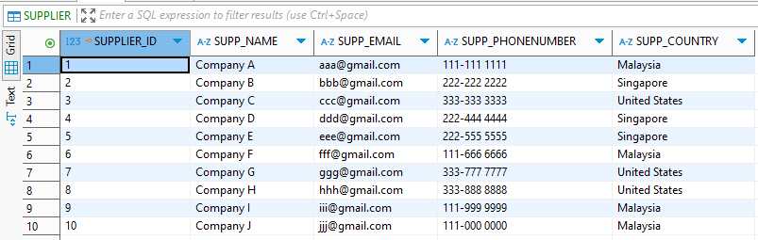

5.2 Product Table
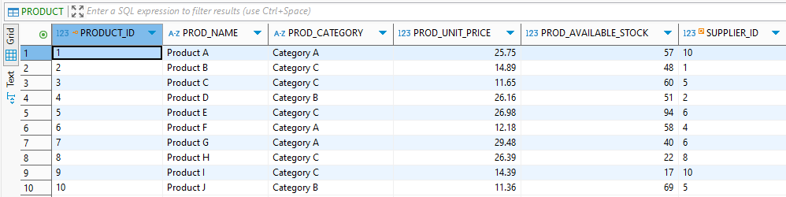

5.3 Promotion Table
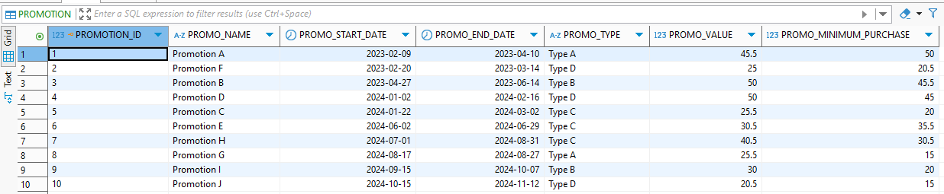

5.4 Delivery Table
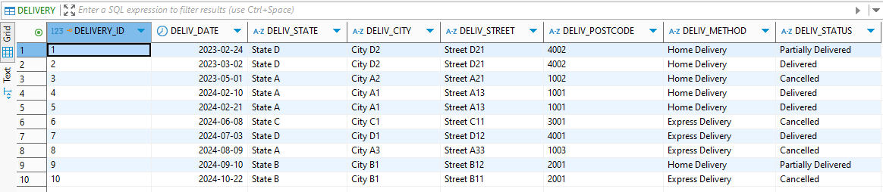

5.5 Customer Table
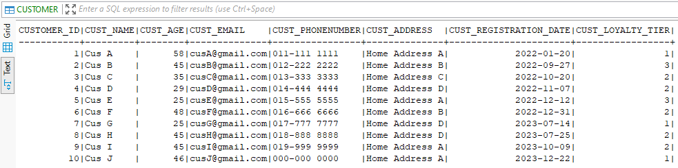

5.6 Time Dimension Table
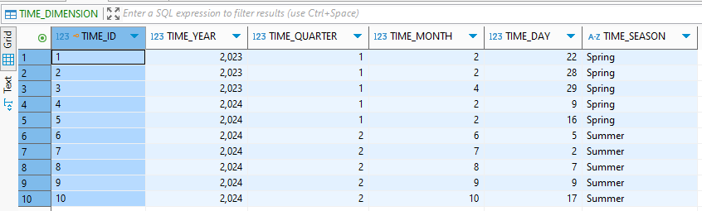

5.7 Payment Table
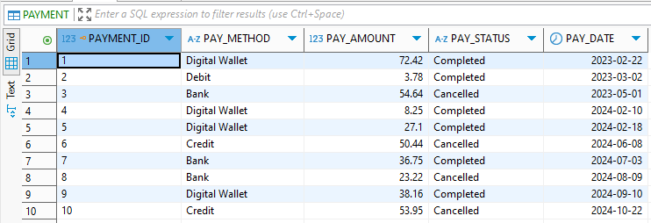

5.8 Sales Table
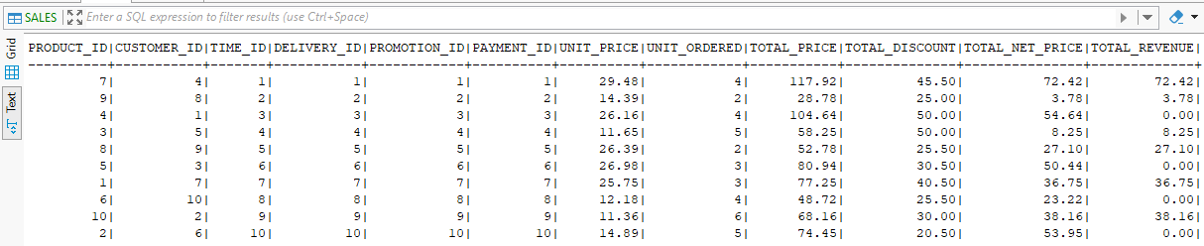

6. Procedural SQLs

6.1 Stored Procedure

6.1.1 GetCustomerSummary
Purpose of Query: The purpose of this stored procedure is to display the summary of customer purchases. The procedure shows important attributes, like total purchases, total spent, and average order value of each customer. All these attributes are essential for segmenting high-value customers, enabling targeted marketing campaigns, and designing effective loyalty programs.
-- The stored PROCEDURE displays the summary of customer purchases.
CREATE PROCEDURE GetCustomerSummary()
LANGUAGE SQL
DYNAMIC RESULT SETS 1
BEGIN
DECLARE cur CURSOR WITH RETURN FOR
SELECT C.CUSTOMER_ID,
C.CUST_NAME,
C.CUST_EMAIL,
C.CUST_PHONENUMBER,
COUNT(S.TOTAL_REVENUE) AS Total_Purchases,
SUM(S.TOTAL_REVENUE) AS Total_Spent,
AVG(S.TOTAL_REVENUE) AS Avg_Order_Value
FROM CUSTOMER C
INNER JOIN SALES S ON C.CUSTOMER_ID = S.CUSTOMER_ID
WHERE S.TOTAL_REVENUE != 0
GROUP BY C.CUSTOMER_ID, C.CUST_NAME, C.CUST_EMAIL, C.CUST_PHONENUMBER
ORDER BY Total_Spent DESC;

OPEN cur;
END

-- Call the stored procedure bu running this code.
CALL GetCustomerSummary();

Before
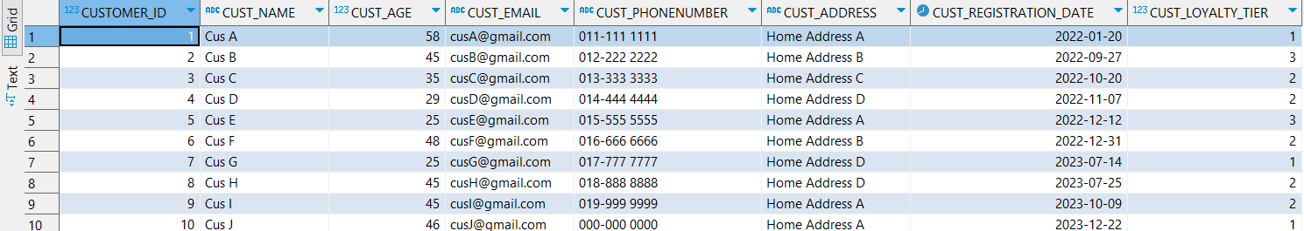
After
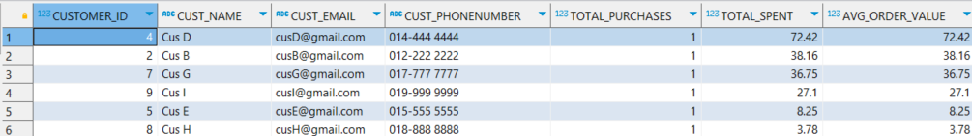

6.1.2 AutoInsert
The purpose of AutoInsert stored procedure is to automate the insertion of new sales, delivery, time, and payment records into the database. It calculates key transaction values such as total price, discount, net price, and revenue based on the input parameters. This procedure ensures data integrity by referencing product and promotion details, and by enforcing business rules on payment methods and statuses. It simplifies the sales entry process, reduces manual errors, and supports consistent data recording across interconnected tables, which is essential for reliable sales reporting and financial tracking.
CREATE PROCEDURE AutoInsert(
IN item_id INT,
IN customer_id INT,
IN discount_id INT,
IN payment_id INT,
IN unit_ordered INT,
IN payment_method VARCHAR(14),
IN payment_status VARCHAR(9),
IN payment_date DATE,
IN time_id INT,
IN delivery_id INT,
IN deliv_date DATE,
IN deliv_state VARCHAR(50),
IN deliv_city VARCHAR(50),
IN deliv_street VARCHAR(50),
IN deliv_postcode VARCHAR(10),
IN deliv_method VARCHAR(20),
IN deliv_status VARCHAR(19)
)
LANGUAGE SQL
BEGIN
DECLARE v_unit_price DECIMAL(6,2);
DECLARE v_total_price DECIMAL(9,2);
DECLARE v_promo_value DECIMAL(6,2);
DECLARE v_promo_minimum_purchase DECIMAL(6,2);
DECLARE v_total_discount DECIMAL(9,2);
DECLARE v_total_net_price DECIMAL(9,2);
DECLARE v_total_revenue DECIMAL(9,2);
DECLARE v_payment_amount DECIMAL(9,2);
DECLARE v_year INT;
DECLARE v_quarter INT;
DECLARE v_month INT;
DECLARE v_day INT;
DECLARE v_season VARCHAR(6);

-- Get unit price from PRODUCT table
SELECT PROD_UNIT_PRICE
INTO v_unit_price
FROM PRODUCT
WHERE PRODUCT_ID = item_id
FETCH FIRST 1 ROW ONLY;

-- Get promotion info
SELECT PROMO_VALUE, PROMO_MINIMUM_PURCHASE
INTO v_promo_value, v_promo_minimum_purchase
FROM PROMOTION
WHERE PROMOTION_ID = discount_id
FETCH FIRST 1 ROW ONLY;

-- Calculations
SET v_total_price = v_unit_price * unit_ordered;

IF v_total_price >= v_promo_minimum_purchase THEN
SET v_total_discount = v_promo_value;
ELSE
SET v_total_discount = 0;
END IF;

SET v_total_net_price = v_total_price - v_total_discount;
SET v_total_revenue = v_total_net_price;
SET v_payment_amount = v_total_net_price;

-- Calculate time values
SET v_year = YEAR(payment_date);
SET v_month = MONTH(payment_date);
SET v_day = DAY(payment_date);
SET v_quarter = (v_month - 1) / 3 + 1;

SET v_season = CASE
WHEN v_month IN (3, 4, 5) THEN 'Spring'
WHEN v_month IN (6, 7, 8) THEN 'Summer'
WHEN v_month IN (9, 10, 11) THEN 'Autumn'
ELSE 'Winter'
END;
-- Insert into PAYMENT
INSERT INTO TIME_DIMENSION (
TIME_ID, TIME_YEAR, TIME_QUARTER, TIME_MONTH, TIME_DAY, TIME_SEASON
) VALUES (
time_id, v_year, v_quarter, v_month, v_day, v_season
);
-- Insert into PAYMENT
INSERT INTO DELIVERY (
DELIVERY_ID, DELIV_DATE, DELIV_STATE, DELIV_CITY, DELIV_STREET,
DELIV_POSTCODE, DELIV_METHOD, DELIV_STATUS
) VALUES (
delivery_id, deliv_date, deliv_state, deliv_city, deliv_street,
deliv_postcode, deliv_method, deliv_status
);
-- Insert into PAYMENT
INSERT INTO PAYMENT (
PAYMENT_ID, PAY_METHOD, PAY_AMOUNT, PAY_STATUS, PAY_DATE
)
VALUES (
payment_id, payment_method, v_payment_amount, payment_status, payment_date
);

-- Insert into SALES
INSERT INTO SALES (
PRODUCT_ID, CUSTOMER_ID, TIME_ID, DELIVERY_ID,
PROMOTION_ID, PAYMENT_ID, UNIT_PRICE, UNIT_ORDERED,
TOTAL_PRICE, TOTAL_DISCOUNT, TOTAL_NET_PRICE, TOTAL_REVENUE
)
VALUES (
item_id, customer_id, time_id, delivery_id,
discount_id, payment_id, v_unit_price, unit_ordered,
v_total_price, v_total_discount, v_total_net_price, v_total_revenue
);
END

CALL AutoInsert(
5, -- product_id
5, -- customer_id
5, -- promotion_id
23, -- payment_id
5, -- unit_ordered
'Bank', -- payment_method
'Completed', -- payment_status
DATE '2025-05-20', -- payment_date
23, -- time_id
23, -- delivery_id
DATE '2025-05-22', -- deliv_date
'State C', -- deliv_state
'City C3', -- deliv_city
'Street C33', -- deliv_street
'1005', -- deliv_postcode
'Express Delivery', -- deliv_method
'Partially Delivered' -- deliv_status

);

Before
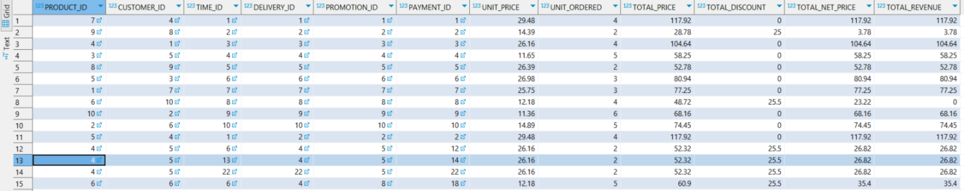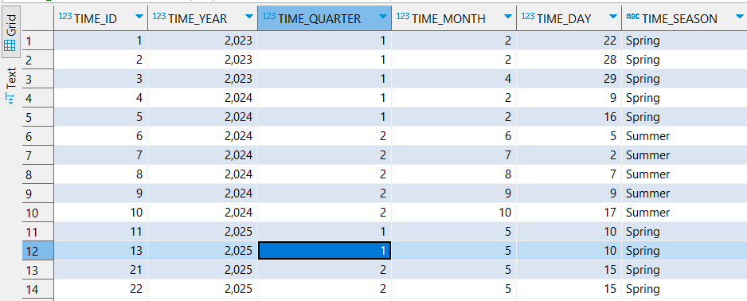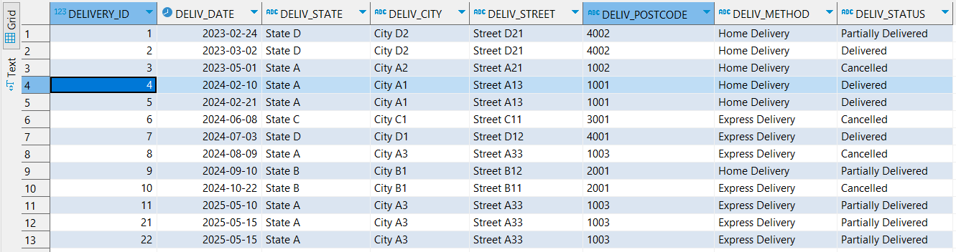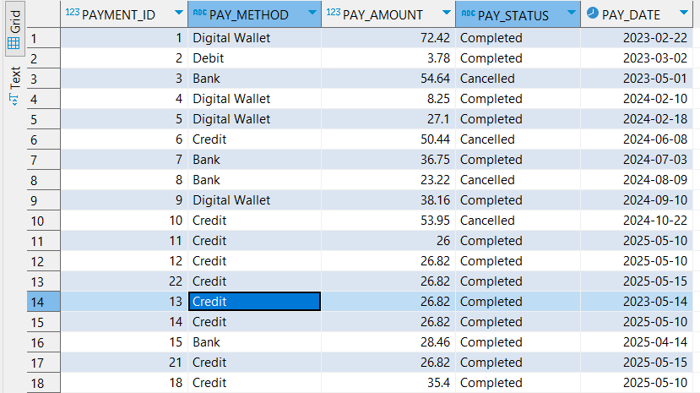

After
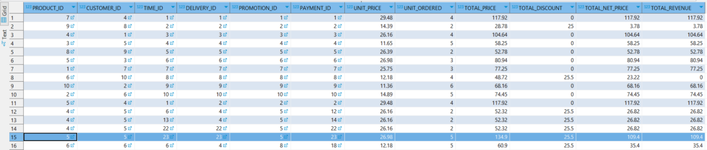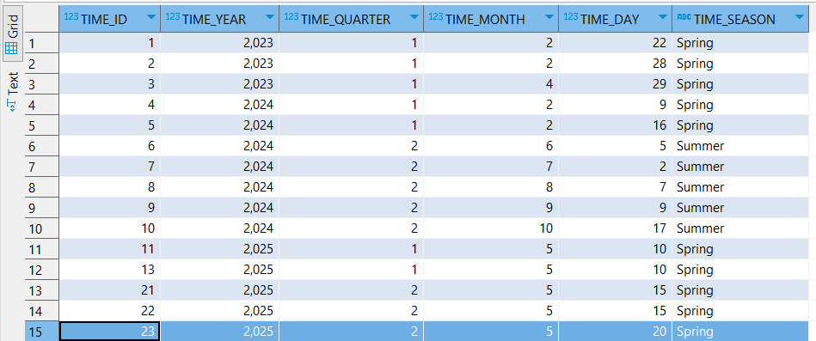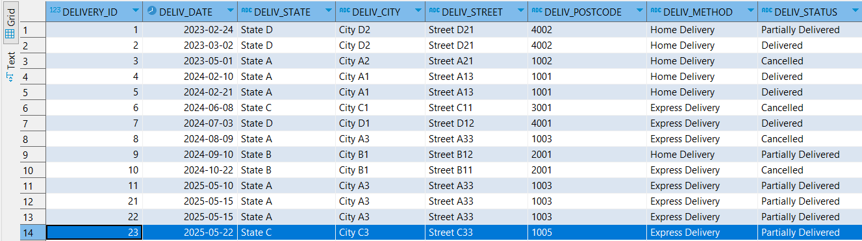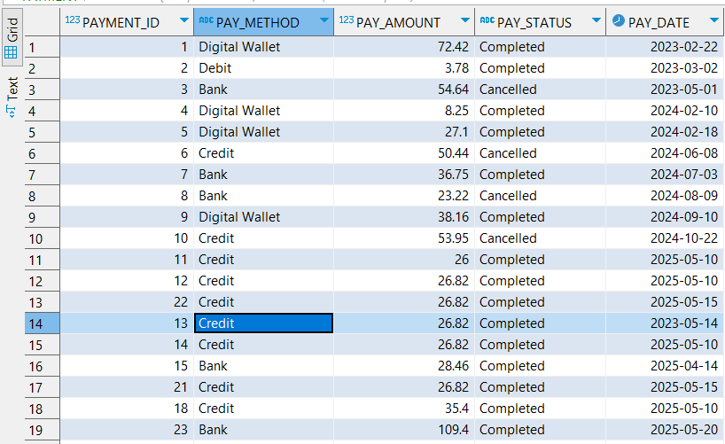

6.2 Trigger

6.2.1 AfterSaleInsert
Purpose of Query : The AfterSaleInsert trigger is executed automatically after a new record is inserted into the SALES table. Therefore, it updates the available stock after each purchase. This trigger is important because it keeps the PROD_AVAILABLE_STOCK synchronized between the sales and inventory of each product without manual updates each day.
-- The trigger updates the available stock after each purchase
CREATE TRIGGER AfterSaleInsert
AFTER INSERT ON SALES
REFERENCING NEW AS N
FOR EACH ROW
MODE DB2SQL
UPDATE PRODUCT
SET PROD_AVAILABLE_STOCK = PROD_AVAILABLE_STOCK - N.UNIT_ORDERED
WHERE PRODUCT_ID = N.PRODUCT_ID;

-- Insert data into Sales to see trigger in action, available stocks for product_id 5 should decrease
INSERT INTO SALES VALUES
(5,4,1,2,2,2,29.48,4,117.92,45.50,72.42,72.42);

Before
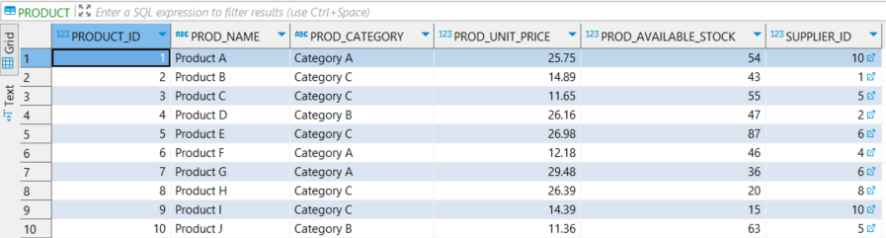
After
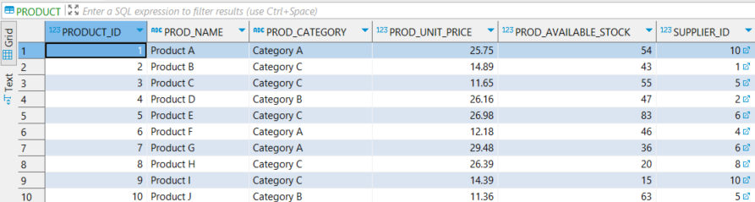

6.2.2 PreventDuplicate
Purpose of Query : The PreventDuplicate trigger is executed automatically before a new record is inserted into the SALES table. It checks whether a sale with the same customer, product, time, delivery, and payment combination already exists. If a duplicate is fo und, the trigger prevents the insertion and raises an error. This trigger is important because it ensures data integrity by preventing unintentional duplicate entries in the sales records, which could lead to inaccurate reporting and analysis in the data warehouse.
CREATE TRIGGER PreventDuplicate
BEFORE INSERT ON SALES
REFERENCING NEW ROW AS N
FOR EACH ROW MODE DB2SQL

BEGIN
DECLARE v_count INTEGER;

SELECT COUNT(*) INTO v_count
FROM SALES
WHERE PRODUCT_ID = N.PRODUCT_ID
AND CUSTOMER_ID = N.CUSTOMER_ID
AND TIME_ID = N.TIME_ID
AND DELIVERY_ID = N.DELIVERY_ID
AND PAYMENT_ID = N.PAYMENT_ID;

IF v_count > 0 THEN
SIGNAL SQLSTATE '75000'
SET MESSAGE_TEXT = 'Duplicate sale detected: Same customer, product, time_id, delivery_id, and payment_id already exist.';
END IF;
END

-- Insert data into Sales to see trigger in action, it should show error code 75000.
INSERT INTO SALES VALUES
(7, 4, 1, 1, 6, 1, 29.48, 4, 117.92, 0.00, 117.92, 117.92);
Before
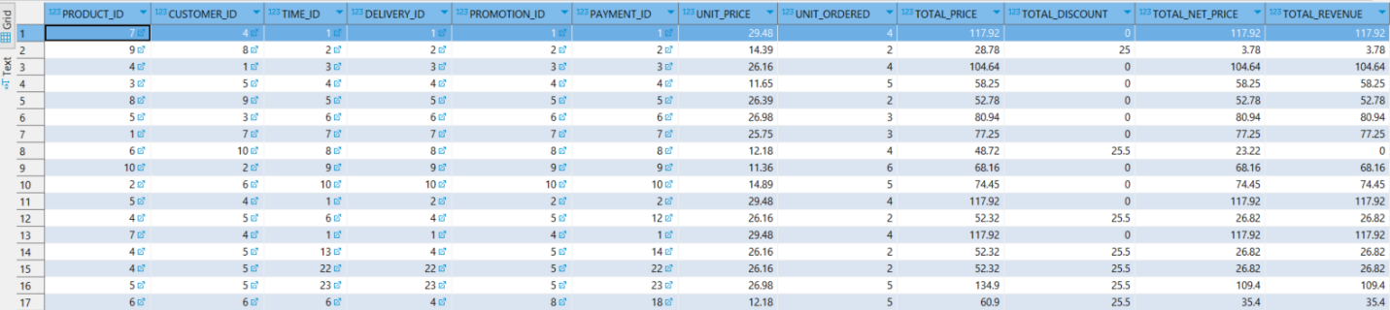
After

6.3 User-Defined Functions
Purpose of Query : The function takes a start, and end date as input before returning SALES within the given PAY_DATE range. This is useful for generating time-specific reports, analyzing sales trends, or evaluating campaign performance within a defined period.

-- The function takes a start and end date, and returns SALES within the given PAY_DATE range
CREATE FUNCTION GET_SALES_BY_DATE_RANGE (start_date DATE, end_date DATE)
RETURNS TABLE (
PRODUCT_ID INTEGER,
CUSTOMER_ID INTEGER,
TIME_ID INTEGER,
DELIVERY_ID INTEGER,
PROMOTION_ID INTEGER,
PAYMENT_ID INTEGER,
UNIT_PRICE DECIMAL(6,2),
UNIT_ORDERED INTEGER,
TOTAL_PRICE DECIMAL(9,2),
TOTAL_DISCOUNT DECIMAL(9,2),
TOTAL_NET_PRICE DECIMAL(9,2),
TOTAL_REVENUE DECIMAL(9,2)
)
LANGUAGE SQL
READS SQL DATA
RETURN
(
SELECT
S.PRODUCT_ID,
S.CUSTOMER_ID,
S.TIME_ID,
S.DELIVERY_ID,
S.PROMOTION_ID,
S.PAYMENT_ID,
S.UNIT_PRICE,
S.UNIT_ORDERED,
S.TOTAL_PRICE,
S.TOTAL_DISCOUNT,
S.TOTAL_NET_PRICE,
S.TOTAL_REVENUE
FROM SALES S
JOIN PAYMENT P ON S.PAYMENT_ID = P.PAYMENT_ID
WHERE DATE(P.PAY_DATE) BETWEEN start_date AND end_date
AND P.PAY_STATUS = 'Completed'
)

-- Run this query to activate the function
SELECT * FROM TABLE(GET_SALES_BY_DATE_RANGE('2023-01-01', '2023-12-31'));

Before
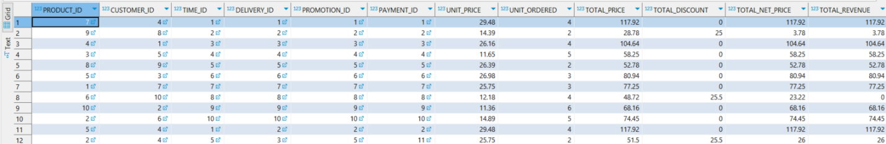
After

7. Construct SQLs

7.1 Complex Query with Joins of at Least 3 Tables
Purpose of Query: This query is used to view the top 5 best-selling products across all suppliers in terms of total units ordered. By using two JOIN operations to combine SALES, PRODUCT, and SUPPLIER tables, the query identifies which supplier-product has the highest sales volume. Metrics such as number of transactions, total units sold, average unit price, and total revenue generated are aggregated into SALES_COUNT, TOTAL_UNITS, AVG_PRICE, and TOTAL_REVENUE. The results are grouped by supplier and product, sorted in descending order of total units sold while limiting it to only the first 5 data columns. This query allows the business to prioritize certain products in the online grocery store to increase total revenue.
SELECT
s.SUPP_NAME,
p.PROD_NAME,
COUNT(*) AS SALE_COUNT,
SUM(sa.UNIT_ORDERED) AS TOTAL_UNITS,
AVG(sa.UNIT_PRICE) AS AVG_PRICE,
SUM(sa.TOTAL_REVENUE) AS TOTAL_REVENUE
FROM
SALES sa
JOIN
PRODUCT p ON sa.PRODUCT_ID = p.PRODUCT_ID
JOIN
SUPPLIER s ON p.SUPPLIER_ID = s.SUPPLIER_ID
GROUP BY
s.SUPP_NAME, p.PROD_NAME
ORDER BY
TOTAL_UNITS DESC
FETCH FIRST 5 ROWS ONLY;

Output: The query shows a comprehensive view of the best performing product by supplier name and product name. It calculates the sale counts, total units ordered, average price per product, and total revenue generated, providing a clear insight into product performance.
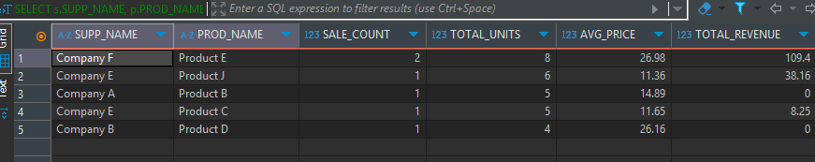

7.2 Group by/Group by Rollup/Group by Cube and Having Clause

Purpose of Query: This query is designed to analyze and track product inventory levels across different suppliers and product categories. By using the GROUP BY ROLLUP feature, it generates hierarchical summary data that shows inventory distribution both at the supplier and category level, as well as at a high-level total for all suppliers and categories. The query identifies key metrics such as the total stock available, average stock per product, minimum and maximum stock levels, and the inventory value (calculated by multiplying stock with unit price). This helps to pinpoint potential stock shortages by highlighting areas with low inventory, assess supplier performance in maintaining adequate stock levels, and recognize any disparities in inventory across different categories. It enables businesses to make data-driven decisions about inventory management, reordering strategies, and supplier relationships, ensuring optimal stock levels and better preparedness for meeting customer demand.
SELECT
-- COALESCE is used to replace NULL values in the Supplier column with 'All Suppliers' for the summary rows.
COALESCE(S.SUPP_NAME, 'All Suppliers') AS Supplier,
-- COALESCE is used to replace NULL values in the Category column with 'All Categories' for the summary rows.
COALESCE(P.PROD_CATEGORY, 'All Categories') AS Category,
COUNT(P.PRODUCT_ID) AS Product_Count,
SUM(P.PROD_AVAILABLE_STOCK) AS Total_Stock,
ROUND(AVG(P.PROD_AVAILABLE_STOCK), 2) AS Avg_Stock_Per_Product,
ROUND(MIN(P.PROD_AVAILABLE_STOCK), 2) AS Min_Stock,
ROUND(MAX(P.PROD_AVAILABLE_STOCK), 2) AS Max_Stock,
ROUND(SUM(P.PROD_AVAILABLE_STOCK * P.PROD_UNIT_PRICE), 2) AS Inventory_Value
FROM
PRODUCT P
JOIN SUPPLIER S ON P.SUPPLIER_ID = S.SUPPLIER_ID
GROUP BY ROLLUP(S.SUPP_NAME, P.PROD_CATEGORY)
HAVING
SUM(P.PROD_AVAILABLE_STOCK) > 0
ORDER BY
CASE WHEN S.SUPP_NAME IS NULL THEN 1 ELSE 0 END,
S.SUPP_NAME,
CASE WHEN P.PROD_CATEGORY IS NULL THEN 1 ELSE 0 END,
P.PROD_CATEGORY;

Output: The query provides a detailed breakdown of product inventory levels by supplier and category, including rollup totals for both dimensions. It outputs the number of products in each group, along with the total, average, minimum, and maximum available stock levels. Additionally, it calculates the total inventory value by multiplying available stock with unit price. The results are organized to show subtotals at the supplier and category levels, offering a clear view of stock distribution and value across the supply chain.
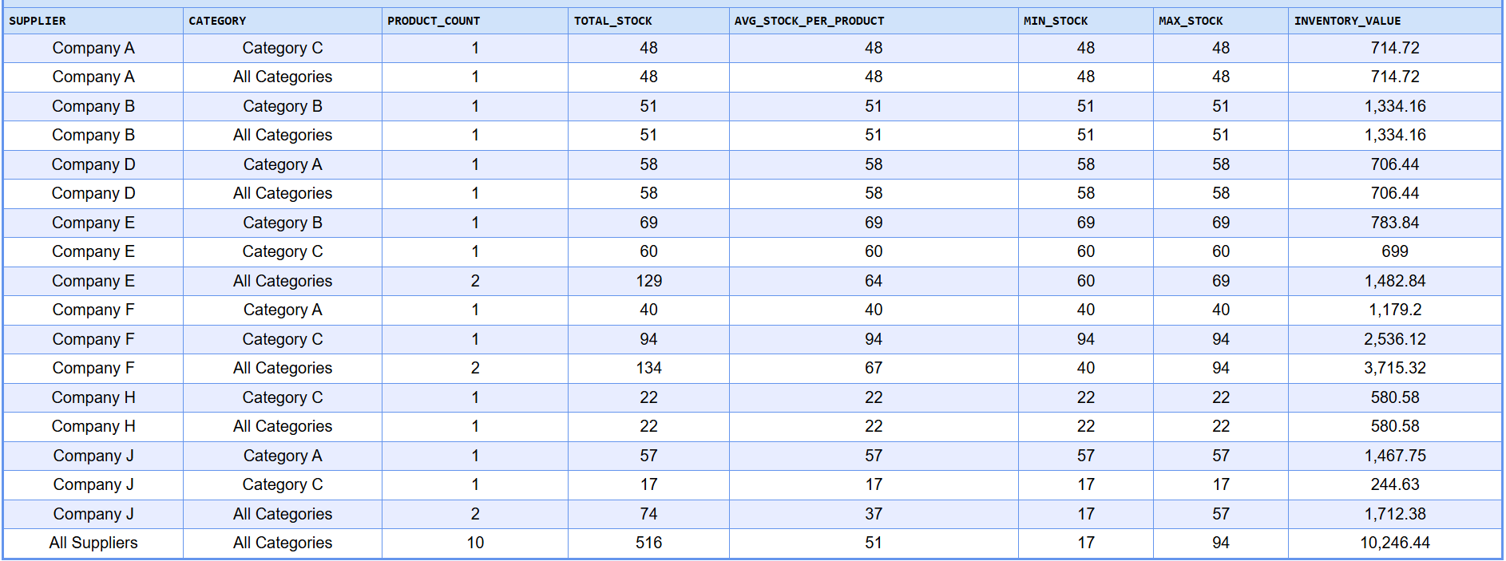


7.3 View
Purpose of Query: This view analyzes individual customer purchasing behavior by product category to uncover specific category preferences across demographic segments such as age and loyalty tier, considering only completed transactions where PAY_STATUS = 'Completed'. It summarizes metrics like purchase frequency, units bought, total spend, and average price per unit for each category, along with the percentage of overall customer spend attributed to that category. This enables more targeted marketing strategies by highlighting which product categories resonate most with different customer profiles, supporting personalized promotions, product recommendations, and loyalty initiatives based on detailed category-level insights rather than broad purchase trends.
CREATE VIEW Customer_Category_Preferences AS
SELECT
C.CUSTOMER_ID,
C.CUST_NAME,
C.CUST_AGE,
C.CUST_LOYALTY_TIER,
P.PROD_CATEGORY,
COUNT(DISTINCT S.TIME_ID) AS Purchase_Months,
COUNT(S.PRODUCT_ID) AS Category_Purchases,
SUM(S.UNIT_ORDERED) AS Total_Units,
SUM(S.TOTAL_REVENUE) AS Category_Spend,
ROUND(SUM(S.TOTAL_REVENUE) / NULLIF(SUM(S.UNIT_ORDERED), 0), 2) AS Avg_Price_Per_Unit,
ROUND(SUM(S.TOTAL_REVENUE) * 100.0 / NULLIF(SUM(SUM(S.TOTAL_REVENUE)) OVER (
PARTITION BY C.CUSTOMER_ID
), 0), 2) AS Category_Spend_Percentage
FROM
CUSTOMER C
JOIN SALES S ON C.CUSTOMER_ID = S.CUSTOMER_ID
JOIN PRODUCT P ON S.PRODUCT_ID = P.PRODUCT_ID
JOIN PAYMENT PAY ON S.PAYMENT_ID = PAY.PAYMENT_ID
WHERE
PAY.PAY_STATUS = 'Completed'
GROUP BY
C.CUSTOMER_ID, C.CUST_NAME, C.CUST_AGE, C.CUST_LOYALTY_TIER, P.PROD_CATEGORY;

-- Query the view
SELECT * FROM Customer_Category_Preferences
ORDER BY CUST_LOYALTY_TIER DESC, "CATEGORY_SPEND" DESC;

Output: Shows each customer's spending by product category, including purchase frequency, total units bought, total spend, average price per unit, and percentage of their total spending allocated to each category, sorted by loyalty tier and category spend.
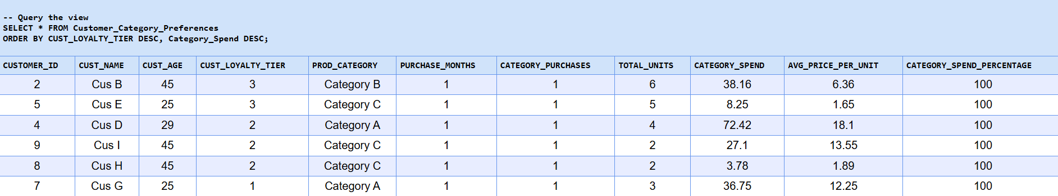

7.4 Two SQL Not Covered in Lecture
Purpose of Query: The use of two SQL elements not covered in the lecture is RANK() with PARTITION BY. This query evaluates promotion performance across different seasons using window functions to reveal optimal promotion timing and types. It calculates the Seasonal Revenue Rank by using RANK() partitioned by season to identify top-performing promotions within each seasonal group, ensuring fair comparisons unaffected by seasonal variation. Additionally, it computes the Revenue Percentage using the following calculation:
Revenue_Percentage = ROUND(Seasonal_Revenue * 100.0 / SUM(Seasonal_Revenue) OVER (PARTITION BY TIME_SEASON), 2)
Revenue Percentage divides each promotion's revenue by its total seasonal revenue, highlighting each promotion's relative contribution within its season. The Average Transaction Value is derived from total revenue divided by transaction count, offering insight into promotion effectiveness in terms of value per transaction. The partitioned ranking prevents seasonal bias when comparing promotions, while the revenue percentage clearly shows each promotion’s market share within its season. This detailed breakdown helps businesses compare which promotions perform best in each season and how much they contribute relative to others.

WITH SeasonalPromoPerformance AS (
SELECT
PR.PROMO_TYPE,
T.TIME_SEASON,
SUM(S.TOTAL_REVENUE) AS Seasonal_Revenue,
COUNT(*) AS Transaction_Count,
AVG(S.TOTAL_REVENUE) AS Avg_Transaction_Value
FROM
SALES S
JOIN PROMOTION PR ON S.PROMOTION_ID = PR.PROMOTION_ID
JOIN TIME_DIMENSION T ON S.TIME_ID = T.TIME_ID
WHERE
S.TOTAL_REVENUE > 0
GROUP BY
PR.PROMO_TYPE, T.TIME_SEASON
)
SELECT
PROMO_TYPE,
TIME_SEASON,
Seasonal_Revenue,
Transaction_Count,
Avg_Transaction_Value,
RANK() OVER (
PARTITION BY TIME_SEASON
ORDER BY Seasonal_Revenue DESC
) AS Season_Rank,
ROUND(Seasonal_Revenue * 100.0 / SUM(Seasonal_Revenue) OVER (
PARTITION BY TIME_SEASON
), 2) AS Revenue_Percentage
FROM
SeasonalPromoPerformance
ORDER BY
TIME_SEASON, Season_Rank;

Output: The output shows each promotion type's performance by season, including total revenue, transaction count, average transaction value, seasonal rank (1=top performer), and revenue percentage contribution, sorted by season and rank to highlight top-performing promotions per season.
